

**2015 SHRM-CP/SHRM-SCP**

**Certification Exam**

**Winter Testing Window: Dec. 1, 2015 - Feb. 15, 2016**

* Applications Accepted: May 1, 2015
* Regular Application Deadline: October 16, 2015
* Late Application Deadline: November 13, 2015

***Exam Prep***

The 2015 SHRM Learning System® for SHRM-CP/SHRM-SCP provides interactive tools and updated content that reflects the SHRM BoCKTM tested on the SHRM-CP and SHRM-SCP exams. Gain a generalist viewpoint, refresh key ideas and concepts, strengthen your understanding of core competencies and increase productivity. The SHRM Learning System is available through:

1. Self-Study: SHRM member: $695 USD, nonmember: $870 USD
2. Instructor-Led programs
   1. 3-Day in-person SHRM Sponsored Seminar, June 27 – 30, 2015, Las Vegas NV; **SHRM member:**$1,395 USD, **nonmember:**$1,670 USD
   2. SHRM Education Partners

*EXAMPLE: University of Arkansas- $1290*

* *Taught by team of 5 experts*
* *One weeknight per week, 12 weeks, 4:30 pm – 7:30 pm (CST)*
* *Face to face for local attendees, video conferencing available through Blackboard; log in to live classes and/or view archived recorded sessions.*
* *Contact Judith Tavano, M.A., SHRM-SCP, SPHR, Director, Professional Development, 855-402-3300 (toll free)*

1. 7-week Virtual Seminar - Tues. & Thur.,May 5 – June 18 | 7:00-8:30 P.M. ET; **SHRM member:**$1,395 USD, **nonmember:**$1,670 USD

***Financial Support***

1. PAHRA scholarship: $750 (provided by the SHRM Foundation)
2. SHRM Scholarships: <http://www.shrm.org/about/foundation/scholarships/pages/shrmfdncertschol.aspx>

**Questions? Need help?**

**Cheryl Moreno, 928-445-0512 or** [**cherylmoreno@msn.com**](mailto:cherylmoreno@msn.com)

**SHRM:** http://shrm.org/certification/pages/default.aspx

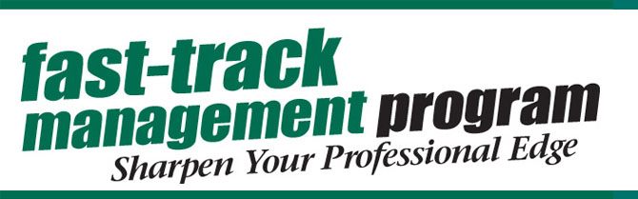

*PAHRA in partnership with Yavapai College's Fast-Track Management Program brings you...*

**BSA223-Human Resource Management (CRN 39274)**

**Oct 19-Dec 12, 2015**

Professor Jolaine Jackson, IPMA-CP, SPHR

**Enjoy convenient online modules to update your human resource management knowledge and participate in engaging in-person sessions*:**

* Wednesday Evenings, October 21, 28, November 4, 11, 18, December 2, 9
* 5:30-7:00 pm
* Prescott Campus- Bldg 2-216 & Clarkdale Campus Bldg G-102 (Streamed live ITV)

*\*This is an on-line course. In-person sessions optional; session attendance and subsequent topic application will be in lieu of (i.e.) quiz online or discussion board, TBD. Three in-person sessions will be conducted by professor (Oct 21, Nov 11, Dec 9), and three will be conducted by PAHRA Guest Lecturer (Oct 28, Nov 4, Nov 18). December 2 reserved for review/catch-up.*

Take Advantage of This Great Opportunity In 3 Easy Steps:

1. Admission to YC accomplished through on-line registration process with drivers license for proof of residency. Register online at [www.yc.edu](http://www.yc.edu/), and use course registration number (CRN) 39274 for BSA223-Human Resource Management. Tuition $225 + fees.
2. Purchase the text HR3 by Denisi/Griffin; Cengage with Coursemate Access Code, ISBN13: 978-1-285-86757-1 $79 + Tax
3. Attend the first session in person on Wednesday, October 21, 2015.

**Questions? Need help?**

**Joy D'Angelo, Yavapai College, 928.776.2343 or** [**joy.dangelo@yc.edu**](mailto:joy.dangelo@yc.edu)

**Cheryl Moreno, PAHRA, 928-445-0512 or** [**cherylmoreno@msn.com**](mailto:cherylmoreno@msn.com)